Matthew Hoffman

CpE 403 – Advanced Embedded Systems

Lab 7

# Task 1:

Task 1 asked to convert lowercase alpha characters to uppercase and vice-versa. This was accomplished with the char convert_char(void) function seen in the source code from Figure 1. When outputting back to the terminal this function was simply called within the interrupt handler to output the converted character rather than the inputted char from the keyboard.

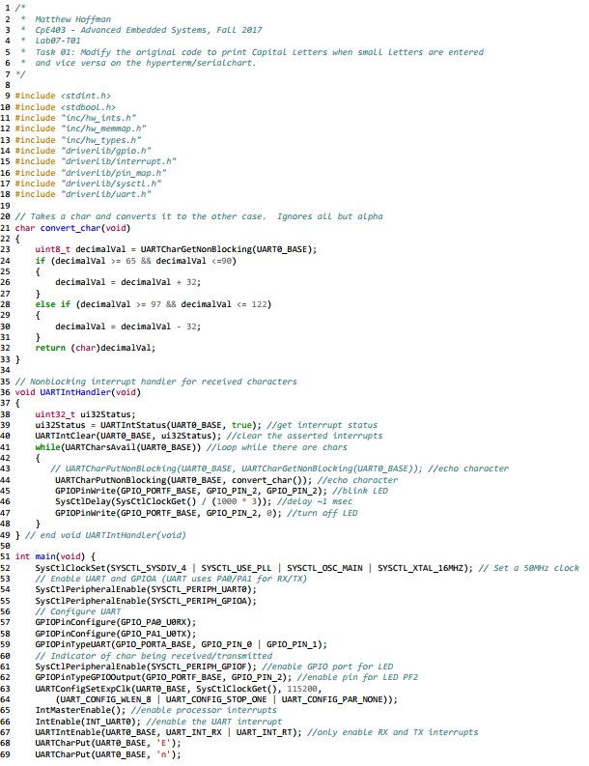 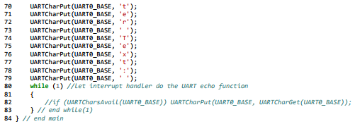

Figure 1. Lab07-T01 Source Code

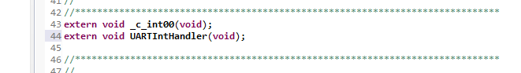

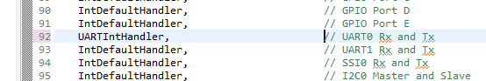

Figure 2. Lab07-T01 Startup CCS, Interrupt Definition File

# Task 2:

Task 2 asked to continuously display the temperature of the device. The code for the ADC was taken from a previous lab and simply needed the UART functionality. To handle this two functions were needed. One to convert the integer values to characters and another to reverse the array that these values would be stored in. This was needed as when converting integer to characters it becomes reversed. The reverse function simply ‘flips’ an array so that the correct string value is stored and printed to the screen.

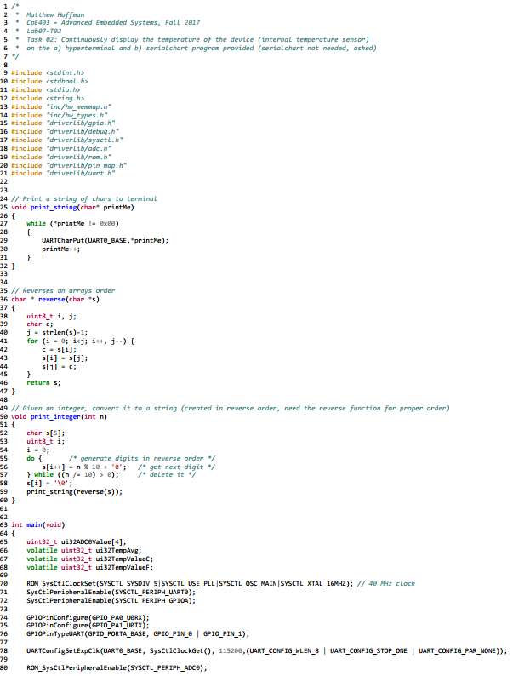 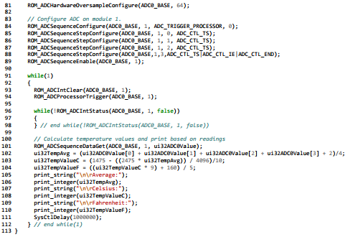

Figure 3. Lab07-T02 Source Code